ONLINE RESOURCES

WEBSITE | WEBSITE URL | DESCRIPTION FEATURES
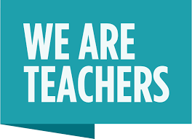 | https://www.weareteachers.com/best-virtual-field-trips/ | Virtual field trips
 | https://www.discoveryeducation.com/community/virtual-field-trips/ | Virtual field trips
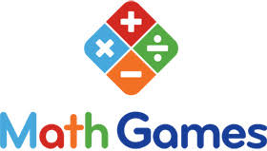 | https://www.mathgames.com/ | Math games
 | https://www.google.com/earth/ | “A computer program that renders a 3D representation of Earth based primarily on satellite imagery.”
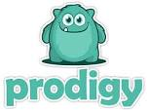 | https://www.prodigygame.com/ | “. . . interactive math game where success depends on correctly answering skill-building math questions”
 | https://tinyurl.com/yc6ljkmp | Personalized learning for students in Math, Language Arts, Science, Social Studies and Spanish.
 | https://kids.nationalgeographic.com/ | children's magazine published by the National Geographic Society.
 | https://www.storylineonline.net/library/ | Streamed videos featuring celebrated actors reading children’s books alongside creatively produced illustrations.
 | https://www.readworks.org/ | Resources to teach the concepts of reading comprehension to students in grades K-6
 | https://www.brainpop.com/ | “Engaging learning games, animated movies, and activities. Designed with relevance, depth, and humor to encourage kids on their unique learning paths.”
 | https://www.dogonews.com/ | “The leading source for current events, news and non-fictional content for Common Core ELA, Science and Social Studies.”
 | https://www.howstuffworks.com/ | “Explanation of thousands of topics, ranging from the flu to black holes to conspiracy theories, with video and illustrations.”
 | https://www.nasa.gov/kidsclub/index.html | NASA provides a safe place for children (pre-k through grade 4) to play as they learn about NASA and its missions.
 | https://sciencebob.com/ | “Find easy science experiments, watch experiment videos, and get Science Fair ideas.”
 | https://www.switchzoo.com/ | “Make new animals, play animal games, build a biome, learn about animals, and hear animal music.”
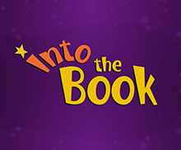 | https://reading.ecb.org/ | “A reading comprehension resource for elementary students and teachers.”
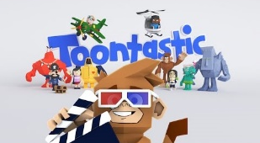 | https://toontastic.withgoogle.com/ | “A creative storytelling app that empowers kids to draw, animate, narrate, and record their own cartoons on their tablet, phone or Chromebook.”
 | https://pbskids.org/ | “Educational games and videos from Curious George, Wild Kratts and other PBS KIDS shows!”
 | https://www.funbrain.com/ | “Funbrain offers hundreds of games, books, comics, and videos that develop skills in math, reading, problem-solving and literacy.”
 | https://www.highlightskids.com/ | “The place for children of all ages to play games and discover new jokes, surveys, answers to science questions, and fun crafts and recipes.”
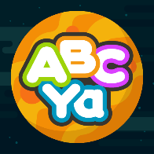 | https://www.abcya.com/ | Educational games for grades PreK through 6 covering topics such as multiplication, parts of speech, typing, pattern recognition, and more.
 | https://www.lakeshorelearning.com/ | Your one-stop teacher supply store! Shop high-quality learning products & teaching resources—plus premium classroom furniture like tables, seating & more!
 | https://www.commonsense.org/education/ | Resource for educators and students to harness the power of technology for learning and life.
 | https://www.edhelper.com/ | Worksheets, learning resources, and math practice sheets for teachers to print. Weekly workbooks for K-8. The homework site for teachers!

